**A Good Deck**

For building a good deck in [Clash Royale](https://clashroyale.com/) isn't that hard. But there are some few things you have to keep in mind. Some say that a good deck must have a good level of cards. I don't think so. Card levels only matters when you are playing on the ladder. **( Ladder means getting ranked up in the local or global player list )**

[](https://3.bp.blogspot.com/-k_DidYqYWnI/W7op56DvY6I/AAAAAAAAAKs/U5JYzINbof41idZnfV1evIVVcAqyVOtrwCLcBGAs/s1600/clash-royale-equilibrio-24-featured.jpg)

**Y**ou don't have to push hard for your cards level. You just have to focus on with what cards you are comfortable playing. If you aren't comfortable with your cards then you can't go too much further. In [Clash Royale](https://clashroyale.com/) official website, there is **a list of XP 1 levelled players**. On the list, top-ranked player's trophy is **4000+** but his card level is poor as his XP is 1. So, the cards level doesn't matter. Here are some tips about**How To Build A Good Deck In Clash Royale**

* **Keeping at least two spells:**

In a deck at least two spells are necessary. I'll name this spells as **one major spell** and another **one minor spell**. A major spell can be **Poison, Fireball, Rocket, Lightning** etc. A major spell will help you counter Three Musketeers or other strong cards or a strong push. If you have a major spell, then countering a strong push will be so much easy.

[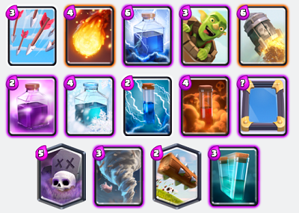](https://1.bp.blogspot.com/-wsPE0-Qf4uw/W7oqEqUhIeI/AAAAAAAAAKw/M5YAeddks5gpyA1eQJprfM_-HYTMXq0DACLcBGAs/s1600/spell-cards.png)

Now let's hear about the **minor spell.** A minor spell can be **Log, Zap, Arrow** etc. When you are down on elixir from your opponent, a minor spell help you **taking less damage**. There are some troops which won't be fully destroyed by Fireball or Poison. Like **Witch, Musketeer, Wizard.** So, on this troops, you have to use both major or minor spell like Fireball or Poison. For fully destroying them **(If you have a high elixir major spell then you have to use both spells)**. Otherwise, they will put a tank in front of these low hp cards and destroy you. **(These interactions are for the same card level opponent)**

* **Having a tank in the deck:**

[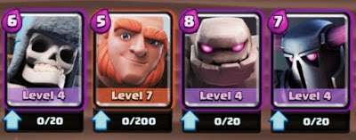](https://2.bp.blogspot.com/-MxxsbYhFg_4/W7oqNO4jS9I/AAAAAAAAAK0/-0Dc9pRwUgsZlPKfNiu-kU2vDG91nZFUgCLcBGAs/s1600/image5.jpeg)

**Tank means a card which will lead your attack from the front.** It can be **Golem, Giant, Royale Giant, Pekka, Hog Rider** etc. These cards have good health for leading an attack. For building a deck you must have a tank or more than one. It's also called a **win condition**.

* **Having good supporting cards:**

A tank is not enough for winning a match. You must have some supporting troops for your tank. **Supporting troops help your tank to lead the attack more strongly**. These cards can be **Witch, Musketeer, Wizard** etc.

* **Legendary cards in the deck:**

**[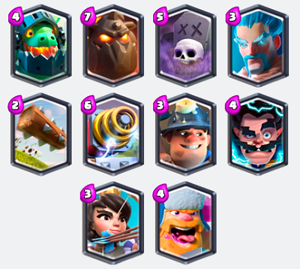](https://4.bp.blogspot.com/-J2AjGhofmmM/W7oqeXaR4GI/AAAAAAAAAK8/DRUf-_AK3fUX_u9c-nKfX4YCYACm5kUngCLcBGAs/s1600/legendary-cards.png)**

Some say that if you don't have any legendary card it weakens your deck. But that's **100% wrong**. Top ladder player **Jack** plays with 2.6 Hog deck which doesn't have any legendary card. So if you don't have any legendary card you don't have to worry. **Legendary cards are not necessary for building a deck.**

* **Sure defending cards:**

**[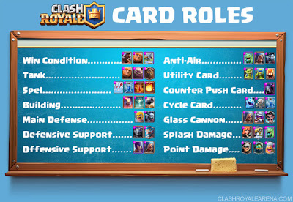](https://3.bp.blogspot.com/-trqicZB-a44/W7oqwjqwcCI/AAAAAAAAALI/5oA4FWMA85MXVBB4916ELvyZrPx2ah1HgCLcBGAs/s1600/clash-royale-card-roles.jpg)**

You have to keep some sure defending cards in your deck. Otherwise, you will lose all the battle. Don't use those defensive cards which can be countered easily. You can have one or more spalsh damaging cards for defence. These cards also help as supporting cards.  If you don't give the fight with your defensive cards you will be **back footed in the whole battle.**

* **Building cards:**

**[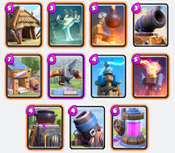](https://3.bp.blogspot.com/-jJeUSDVtjpc/W7oqlePxUCI/AAAAAAAAALA/PXTUnM_9TDEv-rP_eX1jTe5QuORRjAdfwCLcBGAs/s1600/download%2B%25281%2529.jpg)**

If you want to keep building cards in your deck you can. But remember don't use high elixir building cards. That will affect your deck elixir average. The advantage of using a building card can be **baiting your opponent spell**. That will help you create a great push with your tank and supporting cards as opponent don't have any spells.

* **Good elixir average:**

Good elixir average is the most important thing for building a deck. If you used to play with fast cycle deck then your deck should be under 3.0 elixir average. You can use 3.1 to 3.4 elixir deck for a better but less fast cycle deck. If you used to play heavy deck then it's your choice. **As I said you have to play with cards which you are comfortable with.**

**That's all** about **How To Build A Good Deck In Clash Royale** . If you have any other information you may comment below. Have a good clash in the arena with your best deck. Thank you :)